|  |  |  |
| --- | --- | --- |
| **LAB101 Assignment** | **Type:** | **Short Assignment** |
| **Code:** | **C.S.P0047** |
| **LOC:** | **91** |
| **Slot(s):** | **2** |

**Title**

Array and string manipulations.

**Background**

N/A

**Program Specifications**

Implement a program that manages a 100-element array of student names with the following functions:

* Add a student name into the array.
* Remove a student name.
* Search a student name.
* Output student names in ascending orders alphabetically.
* Exit the program.

***Function details:***

1. Function 1: The program displays a menu and asks users to input an option from 1 to 5.

* Users run the program. The program displays and asks users to input an option from 1 to 5:
  1. Add a student name into the array.
  2. Remove a student name.
  3. Search a student name.
  4. Output student names in ascending orders alphabetically.
  5. Exit the program.
* Users input 1: perform Function 2
* Users input 2: perform Function 3.
* Users input 3: perform Function 4.
* Users input 4: perform Function 5.
* Users input 5: exit the program.

1. Function 2: Add a student name

* The program asks users to input a student name.
  + If the array size is already 100, then the program should display: “The list has full. It cannot add a new student.”
  + If the array size is less than 100, then the program add the student name into the array and display the message: “Student has been added to list successfully!”
* Go back to Function 1.

1. Function 3: Remove a student name.

* Search for a student name (Function 4).
* If the student name is not existed, display a message: “Student name doesn’t exist in list.”
* If the student name is in the array, remove the name, and then display the message: “Student name has been removed from list successfully!”
* Go back to Function 1.

1. Function 4: Search a student name.

* If the student name is not existed, return -1.
* If the student name is in the array, return the corresponding index.
* Go back to Function 1.

1. Function 5: Output student names in ascending orders alphabetically.

* After printing student names’ list, go back to Function 1.

***Expectation of User interface:***

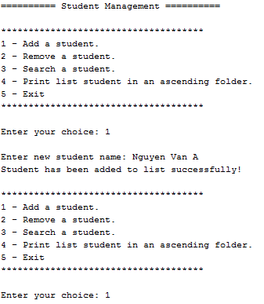

*Add a student name into the array*

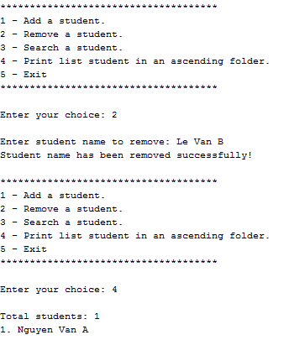

*Remove a student name*

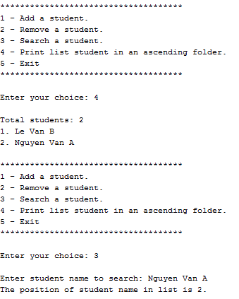

*Search a student name*

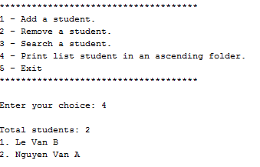

*Output student names in ascending orders alphabetically*

The program exits if users input the number 5.

**Guidelines**

*\* Students should use the given dump_line() function to clear buffer after scanf() function (dump_line(stdin)).*

*Use bubble sort algorithm to sort the array.*